This week we are focusing on improving our balance. Here are a few ideas you can try with items you find around the house.
Pillow Balance
Standing on an unstable surface such as a pillow is a great way to work on standing balance. Have your child stand on a pillow while playing catch, squatting down to pick up toys, or even while coloring at the table. For an added challenge you can stand with feet together so they are touching, standing heel to toe, or standing on one foot.

Hurdles
Stepping over things is a great way to improve single leg balance. The taller the obstacle the more challenging the task is. Try making an obstacle course stepping over a string or painters tape between two chairs. You
can make this activity easier by stepping over a small item on the floor such as a stuffed
animal or pool noodle. The activity will be
more challenging the slower you move so
try stepping over in slow motion.

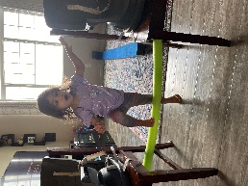
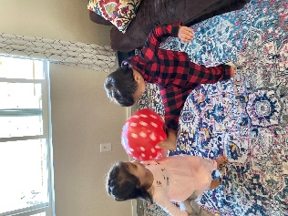
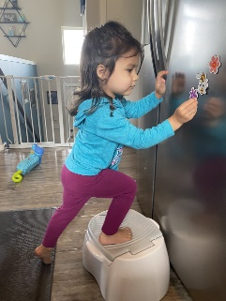
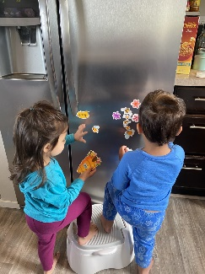
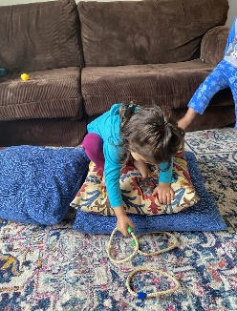
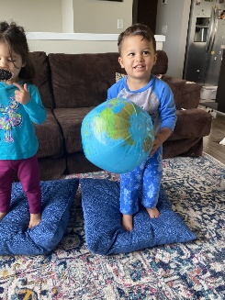
Balloon Volleyball
Throw a balloon up in the air and see how long you can keep the balloon off the floor using only your feet. This is a fun way to improve your single leg balance!

Step Stool Balance
For a great balance challenge stand with one foot on a low step stool, pillow, or small box with the other foot on the floor. While standing you can play with magnets on the fridge, draw pictures at a table, or throw stuffed animals into a laundry basket. How long can you keep your balance?

